### Barrier Washing Extractor

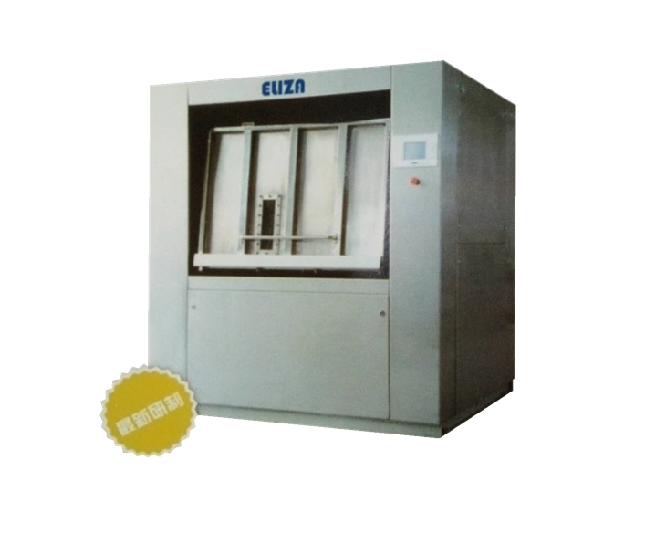

Product Advantages:

1. Eliza Barrier Washer is designed for isolation type washing factories, which satisfies the requirements of sterility, dust-free and antistatic washing. It effectively prevents the textile pollution by separating the washing area into two complete isolated areas. It’s the ideal solution for dust-free industry and hospital washing factory.

2. The automatic control system is adopted.

3. There are multi separated bins in automatic loading system.

4. The air bag is adopted to avoid shaking and noising.

5. It’s easy to operate by double-computer system.

6. This equipment is applied in washing factories for healthcare, food, pharmaceuticals, nuclear power plant, etc.

Technical Parameters(Power Source Voltage 380V)

|  |  |  |
| --- | --- | --- |
| Model | GLx50 | GLx100 |
| Rated Washing Capacity(kg) | 50 | 100 |
| Motor Power(kw) | 5.5 | 7.5 |
| Cold and Hot Water Connection Size(mm) | D40 | D50 |
| Steam Connection Size(mm) | D25 | D50 |
| Outside Dimensions(mm) | 1720x1100x1850 | 1850x1500x1980 |
| Machine Weight (kg) | 1340 | 3200 |